**SPANISH 102: Block 3, Fall 2018**

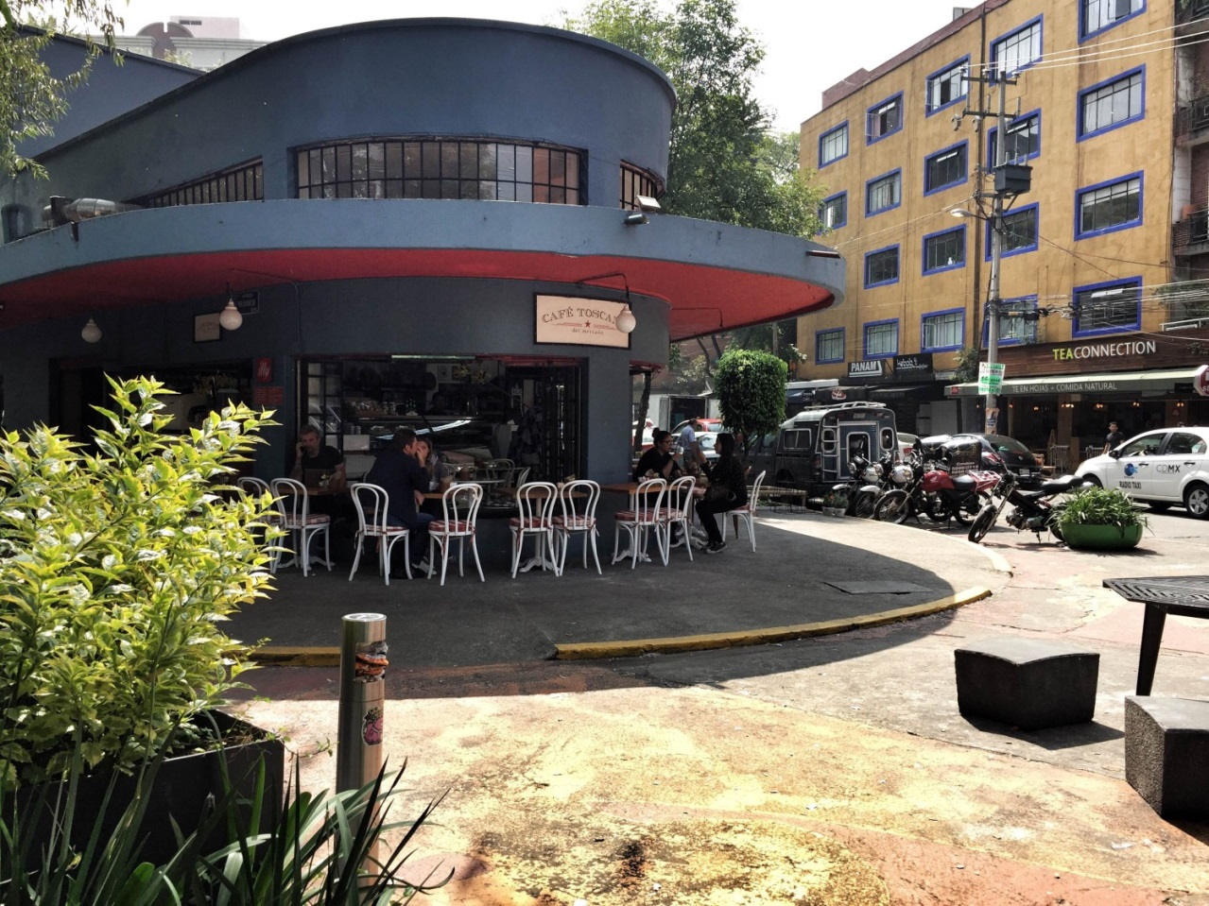

*La casa de Michael en La Ciudad de México*

**Professor**: Michael Mosier

**Office**: 317 College Hall

**Class Hours**: MWF 9-12; TR 9-11 and 1-2 in South Hall 18

**Office Hours**: MTWRF: 12-1 and by appointment

**email**: [mmosier@cornellcollege.edu](mailto:mochoa-shivapour@cornellcollege.edu) **Phone**: x4322

**COURSE DESCRIPTION** Spanish 101-102-103 is a three-term sequence of beginning-level Spanish language at Cornell College.  Students will interact actively in class through group activities, dialogues, and oral work.  *Puntos de* *Partida* as well as the workbooks that accompany the textbook is used in all three courses. A Spanish-English dictionary is recommended. Class activities will be conducted in Spanish. Cultural readings, videos, and short compositions will help students practice and learn language in a cultural context.

**COURSE GOALS**

In the introductory sequence the overarching goal is effective communication in the target language.  There is an emphasis on the four communicative skills: reading, writing, listening, and speaking. We will embed language learning in a cultural and historical context

The Spanish Program strives to meet the educational objectives of Cornell College, especially those related to effective communication, intercultural knowledge, questioning of unexamined assumptions about other cultures, and thinking critically and analytically about language and culture.  At all levels, students will gain experiential knowledge of Hispanic culture through films, music, newspaper articles, and discussions of current events in Spain, Latin America, and the United States.

Our program prepares students to be life-long learners with an appreciation for and sensitivity to other languages and literatures in their cultural and historical context and to acquire an understanding of themselves as participants in a global community.

***This course supports the Educational Priorities and Outcomes of Cornell College with emphases on knowledge, communication, and intercultural literacy.***

**EVALUATION**

3 Exams (40%). Every exam will cover about two chapters.  Last exam is not comprehensive.

10 Quizzes (20%). Quizzes will reflect specific material previously learned in class.

Class participation and mini oral presentations (10%).  Your participation will be graded on volunteering answers in class, paying attention and staying on task. Your grade will be lowered for speaking in English (even in group work), arriving late, and cell phone use/texting in class. Small group presentations will be about a cultural topic of your choice related to one of the countries we’re studying in the textbook. More on mini presentations will be posted on Moodle.

Homework (10%).  Student is responsible for turning in all assignments on time.  Late homework will not be accepted.  Because the answers are in the back of the workbook, you will fill out the activities with one color ink and correct them with a different one. Your grade will be lowered if you do not complete all the activities or if you do not use a different color ink for the corrections. The professor will collect the workbook on exam days.

Final Oral Exam (10%). 5-7 minute presentation in Spanish on a cultural topic of your selection.  More on final oral will be posted on Moodle.

Compositions (10%).   Compositions are an in-class assignment.  You should bring dictionaries.  Topics will be based on a chapter’s themes or a topic of your professor’s choice.  Compositions should be double spaced to allow for corrections.

**ATTENDANCE POLICY**

The accelerated pace of an intensive course supposes no absences.  Only faculty-approved absences and official medical excuses are valid. Official medical excuses require documentation from a health professional (excluding a note from the college’s nurse; she doesn’t give those out so please don’t ask her to supply one). In general, if you miss more than two full days you should discuss dropping the course with the professor.  Your daily attendance (morning and afternoon sessions each count as one class) and class participation are key elements in you final grade.  **After two unexcused absences, your grade will drop by 4%**.  Your grade will continue to drop for every additional absence.

**GENERAL PROCEDURES**

You should plan to spend at least three hours daily studying, preparing for class, and doing homework.  If you spend less than this amount of time on this course, do not complain to the professor about low grades or difficult assignments.  Before coming to class, review grammar and vocabulary, familiarizing yourself with the materials we will be covering that day.  The final oral presentation will be in Spanish, and you will be asked to talk about a topic pre-approved by your professor.  Details will be provided later.  No cell phones or laptops allowed in class.

**ACCOMODATIONS FOR ALL STUDENTS**

Students who need accommodations for learning disabilities must provide documentation from a professional qualified to diagnose learning disabilities. For more information see:

http://www.cornellcollege.edu/academic-support-and-advising/disabilities/index.shtml

Students requesting services may schedule a meeting with the disabilities services Coordinator, Brooke Paulsen, as early as possible to discuss their needs and develop an individualized accommodation plan. Ideally, this meeting would take place well before the start of classes. At the beginning of each course, the student must notify the instructor within the first three days of the term of any accommodations needed for the duration of the course.

**ACADEMIC DISHONESTY**

Cornell College expects all members of the Cornell community to act with academic integrity. An important aspect of academic integrity is respecting the work of others.

A student is expected to explicitly acknowledge ideas, claims, observations, or data of others, unless generally known. When a piece of work is submitted for credit, a student is asserting that the submission is her or his work unless there is a citation of a specific source. If there is no appropriate acknowledgement of sources, whether intended or not, this may constitute a violation of the College’s requirement for honesty in academic work and may be treated as a case of academic dishonesty. The procedures regarding how the College deals with cases of academic dishonesty appear in *The Catalogue,* under the heading “Academic Honesty.”

<http://www.cornellcollege.edu/student-affairs/compass/academic-policies.shtml>

**RECOMMENDATIONS FOR SUCCEEDING IN CLASS**

1. Come prepared to class every day and on time.
2. Pay attention and ask questions.
3. Do your job.  If you feel lost after spending hours in a subject, look for help.  Visit your professor on his office hours.  Schedule meetings with a tutor.  Form a study group.

4.Get exposed to the Spanish language.  Try to immerse yourself as much as possible in Spanish, reading online news, watching TV, listening to songs, watching movies or just browsing the internet in Spanish.  Try to use Spanish with friends and classmates.

5.Diversify the way you study:  write cards with vocabulary, use charts to visualize irregular verbs.  Do the exercises from *Puntos de Partida* companion website: <http://www.mhhe.com/puntos9>.

**RESOURCES:**

## Dictionaries

* General and specialty dictionaries (business, medical, slang, etc.) as well as a thesaurus and word games are available at [Your Dictionary.com](http://www.yourdictionary.com/)
* Freelang dictionary offers a basic Spanish/English Freeware dictionary program at [Freelang.com](http://es.freelang.net/)
* [Diccionarios.com](http://www.diccionarios.com/) is provided by Spes Editorial, publishers of Larousse, Harraps' y **Vox**
* [La Real Academia Española](http://www.rae.es/) offers a Spanish/Spanish dictionary in addition to Español al día, Consulta, Banco de datos, Conjugación verbal, Diccionarios académicos y Biblioteca.
* [WordReference.com](http://www.wordreference.com/es/translation.asp?tranword=welcome) offers a Spanish dictionary provided by Espasa Calpe publishers and Language Forums

## Grammar Review

If you are confused by any grammar topic, please come to my office for a review. If you need additional help, click here for a quick grammar review, [**http://sppo.osu.edu/spanish/courses/classes/grammar.pdf**](http://sppo.osu.edu/spanish/courses/classes/grammar.pdf)**.** It will provide you with the parts of speech, verb conjugations, and basic definitions of language structures.

## Computer Tutorials

Free computer tutorial programs are available at most Public Libraries and also on-line. Type "Spanish language tutorial" into your search engine.

* [net.Tutor](http://liblearn.osu.edu/tutor/) home page provides a menu of all tutorials available. The first or "overview" page of each tutorial provides a table of contents for that lesson and a graphical representation.

**Course Calendar**

|  |  |  |  |
| --- | --- | --- | --- |
| **Octubre**  Lunes 22 | AM | Introducción al curso  Repaso de verbos reflexivos, presente progresivo y ser vs. estar |  |
| Martes 23 | AM | Capítulo 7: Panamá  La comida (200-01);  saber vs. conocer (203) | Prueba 1 |
|  | PM | La comida; saber vs. conocer |  |
| Miércoles 24 | 1-3 | Capítulo 7: pronombres de objeto directo (206-08);  mandatos formales (216-17) | Presentación grupo 1  Prueba 2 |
| Jueves 25 | AM | Capítulo 8: La República Dominicana  De viaje (232-34)  Pronombres de objeto indirecto  (238-40) | Presentación grupo 2  Prueba 3 |
|  | PM | Gustar (243-44) |  |
| Viernes 26 | AM | Capítulo 8: El pretérito (248-50) | Presentación grupo 3  Prueba 4 |
| Lunes 29 | AM | **Examen 1** | **Entregar el workbook** |
| Martes 30 | AM | Capítulo 9: Cuba  Las celebraciones (266-67); las emociones (269-70) | Presentación grupo 4 |
|  | PM | **Composición 1** |  |
| Miércoles 31 | AM | Capítulo 9  El pretérito, partes 2 y 3 (271-72) | Presentación grupo 5  Prueba 5 |
| **Noviembre**  Jueves 1 | AM | Película |  |
|  | PM | Capítulo 9: pronombres de objeto directo e indirecto (279-80) | Presentación grupo 6  Prueba 6 |
| Viernes 2 | AM | Capítulo 10: Puerto Rico  Los pasatiempos (294; 96)  El imperfect (299-301) | Presentación grupo 7  Prueba 7 |
| Lunes 5 | AM | **Examen 2** | **Entregar el workbook** |
| Martes 6 | AM | Capítulo 11: Venezuela  La salud (322-24);    El pretérito y el imperfecto (327-29) | Presentación grupo 8 |
|  | PM | **Composición 2** |  |
| Miércoles 7 | AM | Capítulo 11  Pronombres relativos (335-36)  El ‘se’ recíproco (338) | Presentación grupo 9  Prueba 8 |
| Jueves 8 | AM | Capítulo 12: Colombia  La electronica (354-55)  Los mandatos informales (357-59) | Presentación grupo 10  Prueba 9 |
|  | PM | Los mandatos informales |  |
| Viernes 9 | AM | Introducción al subjuntivo (362) | Prueba 10 |
| Lunes 12 | AM | Oral Final |  |
| Martes 13 | AM | Oral Final |  |
|  | PM | Repaso para el Examen III |  |
| Miércoles 14 | AM | **Examen Final** | **Entregar el workbook** |

**\*\*¡Que tengan un buen Fall Break!\*\***